BDD – CUCUMBER INTEGRATION
with Playwright + TypeScript
Step-by-step setup notes
This guide walks through adding Cucumber (Gherkin/BDD) on top of an existing Playwright automation framework — from installing dependencies to configuring the runner, writing feature files and step definitions, tagging tests, adding hooks, and generating reports.

1. Install & Configure Cucumber

Step 1 — Install Cucumber dependencies
Run the following commands inside your existing Playwright framework:
npm install @cucumber/cucumber
npm install ts-node --save-dev

Step 2 — Install the Cucumber (Gherkin) VS Code extension
Install the "Cucumber (Gherkin) Full Support" extension in VS Code for syntax highlighting, formatting and step auto-complete.
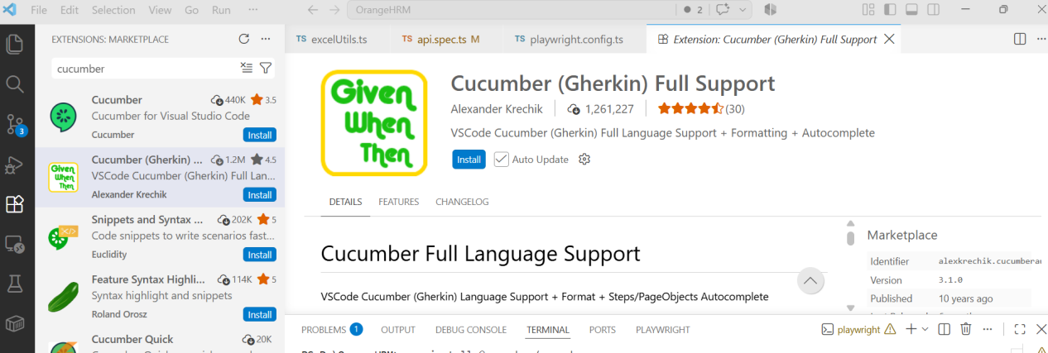
Cucumber (Gherkin) Full Support — VS Code extension

Step 3 — Verify the installation
- Check the @cucumber package exists inside node_modules
- Check the dependency has been added to package.json

Step 4 — Configure tsconfig.json
Make sure the module option is set to commonjs:
{
"compilerOptions": {
"target": "ES2020",
"module": "commonjs",
"lib": ["ES2020"],
"outDir": "./dist",
"strict": true,
"esModuleInterop": true,
"skipLibCheck": true,
"forceConsistentCasingInFileNames": true,
"resolveJsonModule": true,
"moduleResolution": "node",
"allowSyntheticDefaultImports": true,
"declaration": true,
"declarationMap": true,
"sourceMap": true
},
"include": ["**/*.ts"],
"exclude": ["node_modules", "dist"]
}

Step 5 — Check the TypeScript version
npx tsc -v
npm ls typescript

Warning: TypeScript versions below 7.0.2 are not compatible.

Example of an incompatible version found via npm ls typescript:
PS D:\OrangeHRM> npm ls typescript
orangehrm@1.0.0 D:\OrangeHRM
├─┬ ts-node@10.9.2
│ └── typescript@7.0.2 deduped
└── typescript@7.0.2
Fix by uninstalling and reinstalling a supported version:
npm uninstall typescript
npm install --save-dev typescript@5.6.3

2. Create the Feature File

Step 6 — Create a Features folder and a .feature file
Create a Features folder, and inside it add a .feature file named after the scenario, e.g. login.feature:
Features/
└── login.feature

login.feature
Feature: Login

Scenario: Successful login with valid credentials
Given the user is on the login page
When the user enters valid username "Admin" and password "admin123"
Then the user should be redirected to the dashboard page

Scenario Outline: Unsuccessful login with invalid credentials
Given the user is on the login page
When the user enters invalid username "<username>" and password "<password>"
Then an error message should be displayed

Examples:

username | password
Admin | wrongpass
wronguser | admin123

3. Write Step Definitions

Step 7 — Create a stepsDefinition folder
Inside it, create a step definition file with a .steps.ts (or .steps.js) extension — e.g. Login.steps.ts:
import { Given, When, Then } from '@cucumber/cucumber';
import { PageManager } from '../pages/pageManager';
import { expect } from '@playwright/test';
import { chromium } from 'playwright';
import { setDefaultTimeout } from '@cucumber/cucumber';

setDefaultTimeout(60 * 1000);

Given('the user is on the login page', async function () {
const browser = await chromium.launch();
const context = await browser.newContext();
this.page = await context.newPage();
this.pm = new PageManager(this.page);
await this.pm.loginPage.gotoLoginPage();
});

When('the user enters valid username {string} and password {string}', async function (username, password) {
await this.pm.loginPage.login(username, password);
});

Then('the user should be redirected to the dashboard page', async function () {
await expect(this.pm.dashboardPage.dashboardHeading).toBeVisible();
});

Note: this.page and this.pm are set on the Cucumber World object. Once created in one step, they are shared across every step in the scenario.

How matching works: When you run npx cucumber-js --exit, the feature file and step files load via the cucumber.js config. Every Given / When / Then / And / But line in the feature file is matched against step-definition text; wherever it matches, that function runs — step definitions can live in any file, there is no naming restriction. For example, if a feature file's Given matches login.steps and its When matches a different step file, both files' functions still execute in the order the feature file defines.

4. Configure cucumber.js
The cucumber.js runner config differs slightly depending on where the stepsDefinition folder lives.

Option 1 — stepDefinition folder outside the Feature folder
module.exports = {
default: {
requireModule: ['ts-node/register'],
require: ['stepsDefinition/**/*.ts'],
paths: ['feature/**/*.feature'],
format: ['progress']
}
};

Option 2 — stepDefinition folder inside the Feature folder
module.exports = {
default: {
requireModule: ['ts-node/register'],
require: ['feature/stepsDefinition/**/*.ts', 'feature/**/*.ts'],
paths: ['feature/**/*.feature'],
format: ['progress']
}
};
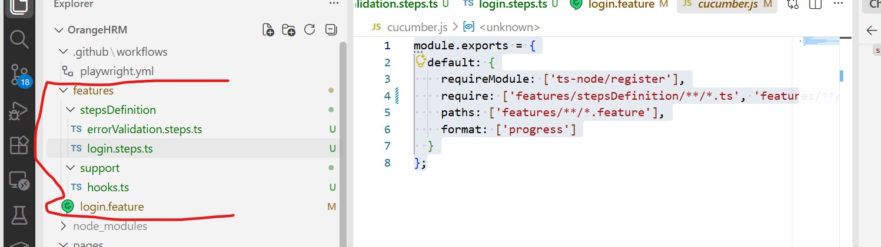
Example project structure: features, stepsDefinition and cucumber.js

5. Tags

Step 8 — Add tags to test cases
Tag scenarios directly above the Scenario line (e.g. @Smoke) so they can be filtered when running tests:
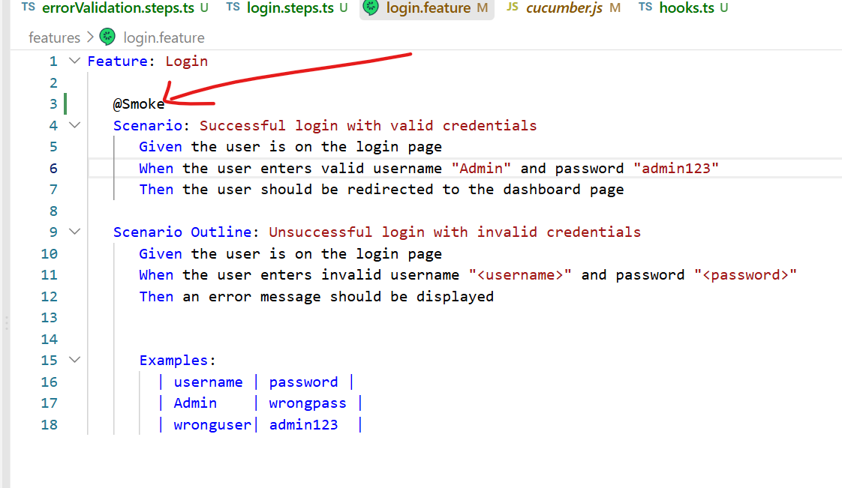
Tagging a scenario with @Smoke in login.feature
Run tests from the terminal using tags:
npx cucumber-js --exit --tags=@Smoke
npx cucumber-js --exit --tags "@Regression"

6. Hooks

Step 9 — Add hooks
Create a support folder inside the Feature folder, and add a hooks.ts file.
Hook types:
Hook | When it runs
Before | Runs before each scenario
After | Runs after each scenario
BeforeAll | Runs once, before all scenarios
AfterAll | Runs once, after all scenarios
BeforeStep | Runs before each step (Given / When / And / Then)
AfterStep | Runs after each step (Given / When / And / Then)

hooks.ts
import { Before, After, AfterStep, Status } from '@cucumber/cucumber';
import { PageManager } from '../../pages/pageManager';
import { chromium } from 'playwright';

Before(async function () {
// Runs before each scenario — perform setup here
console.log('Before hook: Setting up the test environment');
const browser = await chromium.launch({ headless: false });
const context = await browser.newContext();
this.page = await context.newPage();
this.pm = new PageManager(this.page);
});

After(async function () {
// Runs after each scenario — perform cleanup here
console.log('After hook: Cleaning up the test environment');
await this.page.close();
});

AfterStep(async function ({ result }) {
// Runs after each step — capture a screenshot on failure
if (result?.status === Status.FAILED) {
await this.page.screenshot({ path: `screenshots/${Date.now()}.png` });
}
});

7. Reporting
Generate an HTML report while running tagged scenarios:
npx cucumber-js --tags "@Regression" --exit --format html:cucumber-report.html

8. Complete cucumber.js — Reference (Optional)
A fuller cucumber.js configuration with parallel execution, multiple report formats and additional runner options:
module.exports = {
default: {
// Feature files location (relative to current working directory)
paths: ['feature/**/*.feature'],

// Step definitions (must load TypeScript first)
requireModule: ['ts-node/register'],
require: ['feature/stepDefinition/**/*.ts'],

// Parallel execution
parallel: 1,

// Output formats - HTML, JSON, and JUnit reports
format: [
'progress-bar',
'html:cucumber-report.html',
'json:cucumber-report.json',
'junit:cucumber-report.xml'
],

// Format options
formatOptions: {
snippetInterface: 'async-await'
},

// Step timeout in milliseconds
timeout: 60000,

// Retry failed scenarios
retry: 0,

// Strict mode - exit with non-zero code if there are pending/undefined steps
strict: true,

// Dry run mode - validate without executing
dryRun: false,

// Publish results to Cucumber cloud (optional)
publish: false,

// Exit after running scenarios
exit: true
}
};

